# Security in Game Design

In this lesson, students will learn about securing their video games from cyber threats. They will then research the CIA Triad which are widely-accepted security measures that should be guaranteed in every secure system. It stands for Confidentiality, Integrity, and Availability.

* Confidentiality is the protection of information from people who are not authorized to view it.
* Integrity aims at ensuring that information is protected from unauthorized or unintentional alteration.
* Availability is the assurance that systems and data are accessible by authorized users when and where needed.

## Objective

Students will be able to:

* Explain the importance of security in video games
* Identify what the CIA triad is and how it relates to cybersecurity
* Identify which part of the CIA triad has been broken in a given scenario

The video game industry is a multi-billion dollar industry and only continues to grow (Statista.com, 2021). With this kind of revenue, it is no wonder that this particular industry has become a target for cyberattacks at a higher frequency than most in recent years. Security breaches can happen to the best of companies no matter their size or net worth.

As you read the following articles, consider the following questions:

1. What are the top cyber threats in online gaming?
2. What factors have led to the increase in cyber attacks on gaming platforms?
3. List at least 5 things game developers can use to help achieve better security assurance.
4. Of the 5 things listed above, which do you feel could have the biggest impact? Why?
5. The author states “It’s a moral responsibility of the industry to provide [younger players] with a trusted community to play in.” Do you agree that game developers are morally responsible, or should younger players be responsible for protecting their own data? Why?

### Source

Harshwardhan, Kamdi. “Game on: the Need for Cybersecurity in Gaming.” Wipro, Wipro Limited, Dec. 2019, [www.wipro.com/platforms-and-software-products/game-on-the-need-for-cybersecurity-in-gaming/.](http://www.wipro.com/platforms-and-software-products/game-on-the-need-for-cybersecurity-in-gaming/.)

## Securing Your Game: The CIA Triad

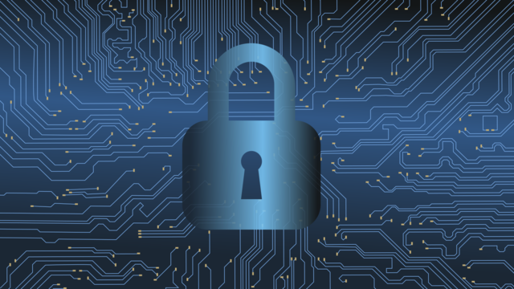

Source: <https://pixabay.com/en/hacking-cybercrime-cybersecurity-3112539/>

## Overview

Protecting both your game and the users is an important part of the process of building games. As more and more games mov online, this becomes even more critical.

## Protecting Digital Information

The concept of Information Security is typically described in terms of the CIA triad (confidentiality, integrity, and authenticity). This is not to be confused with the Central Intelligence Agency (CIA). While building a game will not necessarily involve building out the safeguards for the CIA triad, it is important to understand what safeguards are needed if you deploy your game in an online environment.

[CIA Traid](https://youtu.be/DsWqaQOwsOc)

## Which part of the CIA Triad?

Read the following scenario. Using complete sentences, explain which part of the CIA triad has been broken. Make sure to explain your answer.

1. Tony gets his phone bill in the mail. The bill was supposed to be for $80, but the mail person spilled water on the bill, smearing the ink. The bill now asks for $8.
2. Cynthia is working on her college applications online, when the admissions website crashes. She is unable to turn in her college application on time.
3. Provide an example by creating a short story or explanation of an instance where confidentiality would be broken.
4. Provide an example by creating a short story or explanation of an instance where availability would be broken.
5. Are the following scenarios a breach of confidentiality, integrity or availability? Explain your reasoning.

* In September of 2017, Equifax announced a data breach that exposed the personal information of 147 million people. How did this exposure breach the CIA Triad?
* Downloading what appears to be a legitimate app, a user installs malware which contains keylogging software. What type of breach is the downloading of malware?
* An email phishing attack results in ransomware, in which the files and folders on a computer are encrypted. What type of breach is ransomware?
* How do fake social media accounts breach the CIA Triad?